Jenkins Challenge
Use the below code and implement our CICD stages.
- Source Code:https://github.com/betawins/hiring-app.git
  - Repository contains the application code for the hiring app.
- Create one Declarative pipeline job
- Create one Scripted pipeline job
- Create one multi stage pipeline job
- Create one parallel stage pipeline job

1. Create one Declarative pipeline job
• Opened Jenkins → New Item
• Entered job name: hiring_app_declarative
• Selected Pipeline
• Clicked OK
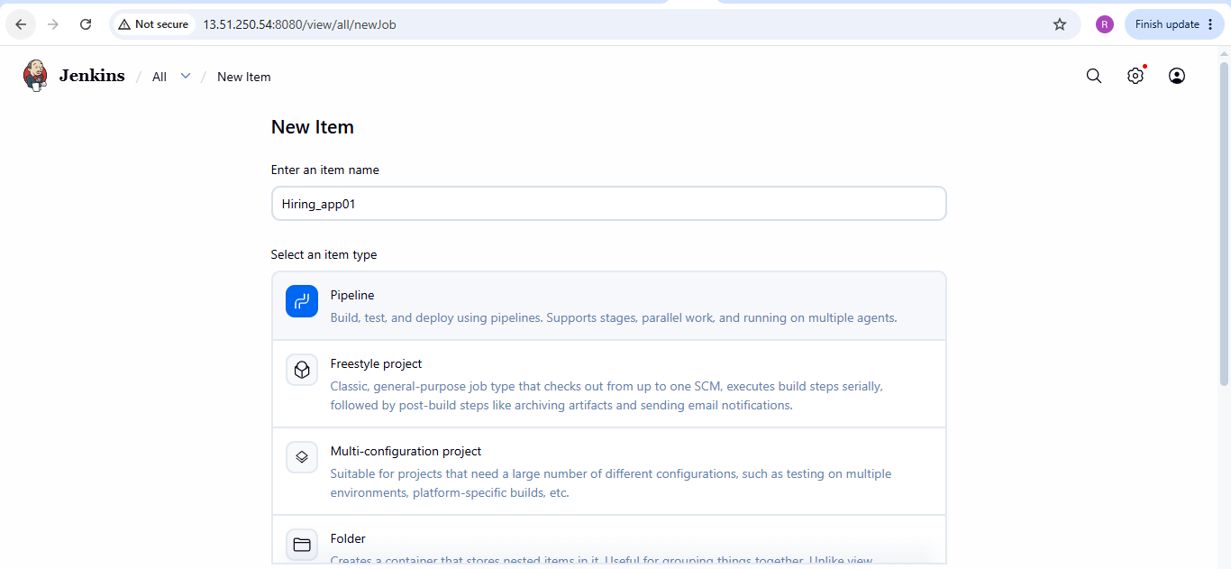

2. Configure the Pipeline
You will see the job configuration page.
Scroll down to the Pipeline section.
Set: Definition: Pipeline script

Then write Declarative Pipeline code into the Script box.
Save the Job
Since pipeline contains SonarQube, Maven, Nexus, Tomcat and Slack, we should make sure these are configured before running it.
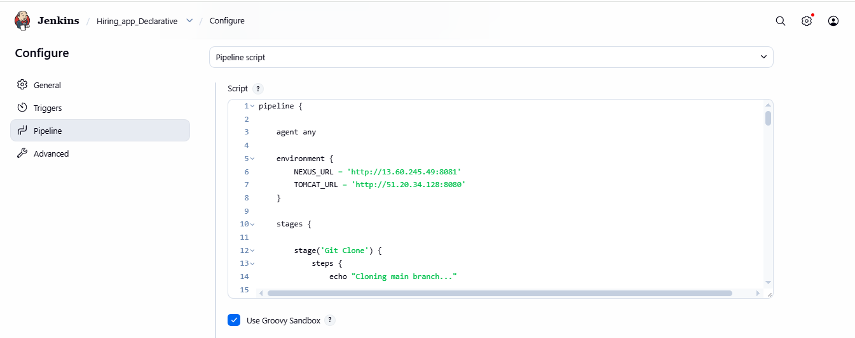

3. Run the Pipeline
On the pipeline job page, Click: Build Now
Jenkins will create: Build #1
Click the build number, for example: #1
Job is successfully executed:
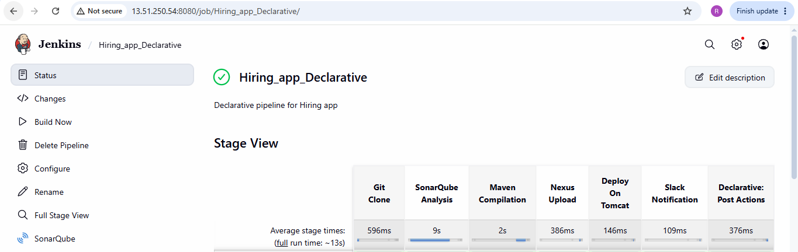

Console output of the job

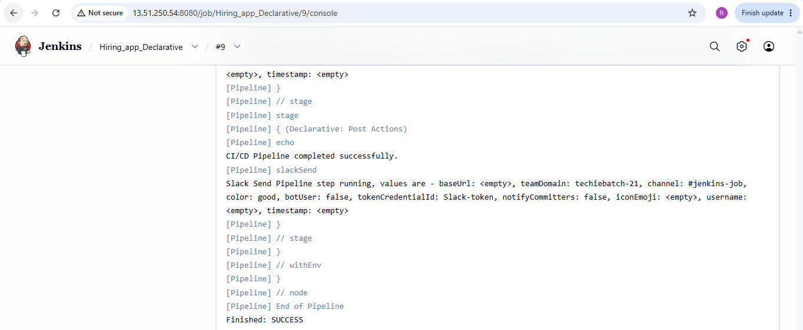

Verified the slack notification:
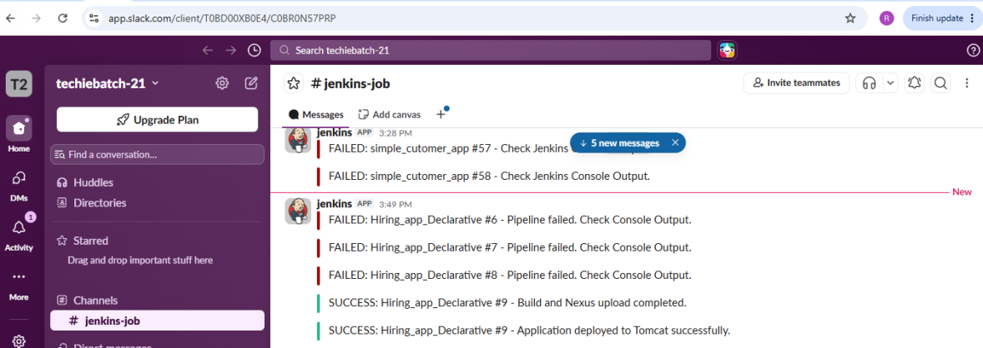
2. Scripted pipeline job:
• Opened Jenkins → New Item
• Entered job name: hiring_app_scripted
• Selected Pipeline
• Clicked OK
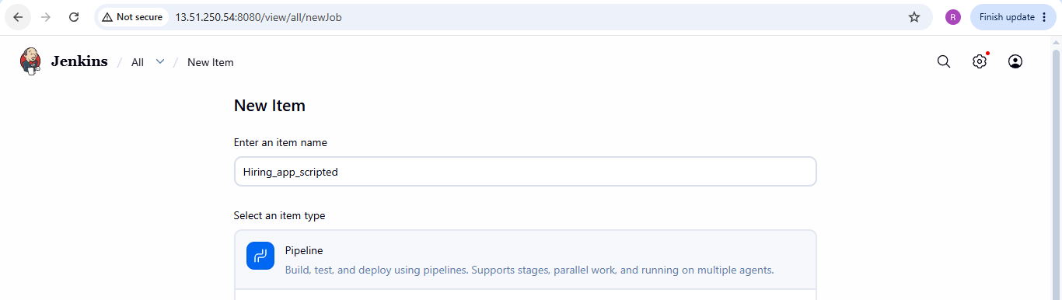

2. Configure the Pipeline
You will see the job configuration page.
Scroll down to the Pipeline section.
Set: Definition: Pipeline script

Then write scripted Pipeline code into the Script box.
Save the Job
Since pipeline contains SonarQube, Maven, Nexus, Tomcat and Slack, make sure these are configured before running it.

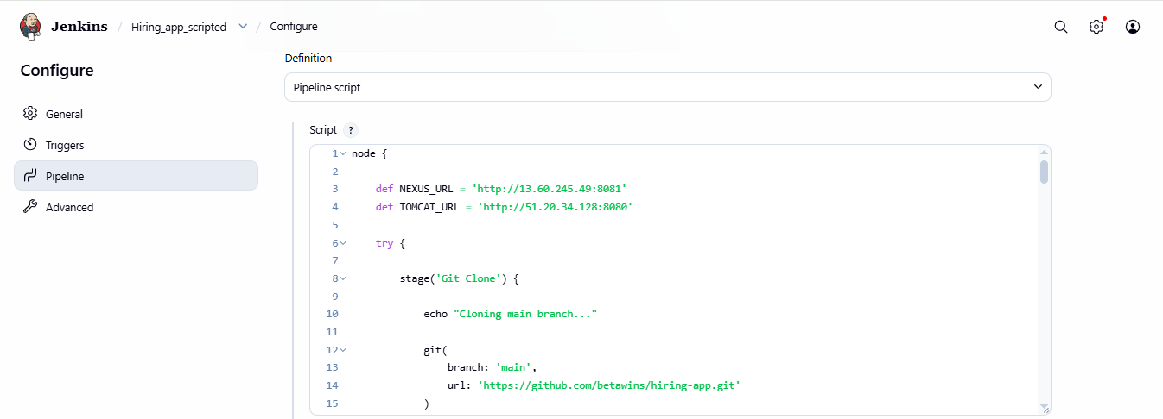

3. Run the Pipeline
On the pipeline job page, Click: Build Now
Jenkins will create: Build #1
Click the build number, for example: #1
Job is successfully executed:
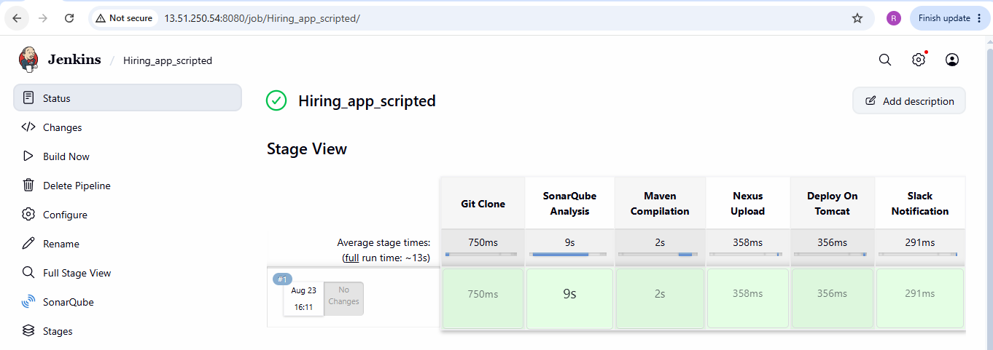
Console output of the job:

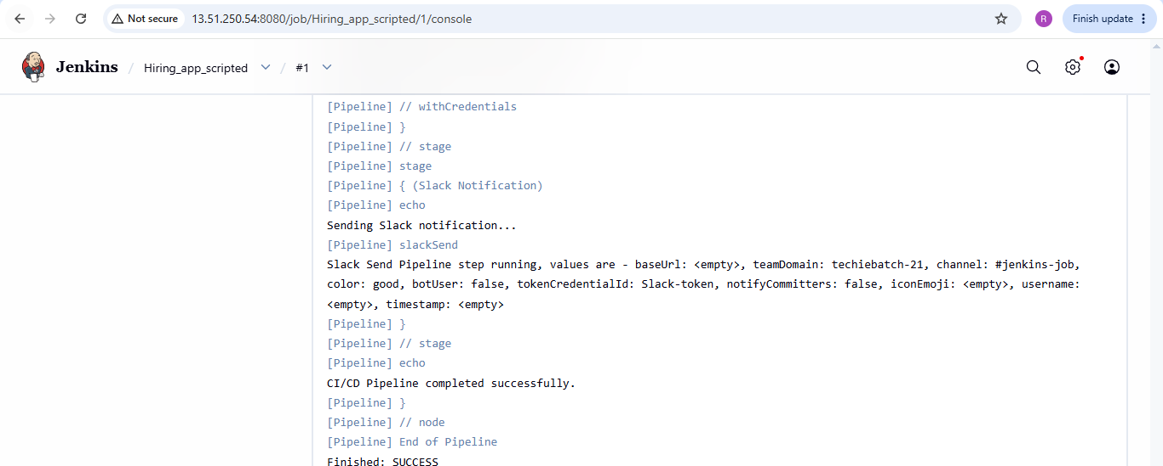

Verified the slack notification:
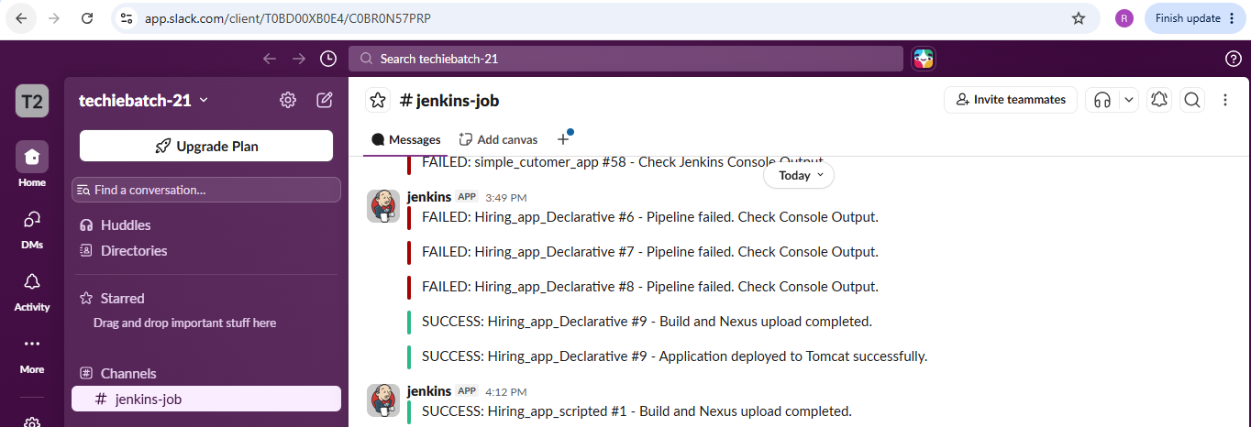
3. Create one Multistage Pipeline job:
• Opened Jenkins → New Item
• Entered job name: Multistage _declarative
• Selected Pipeline
• Clicked OK
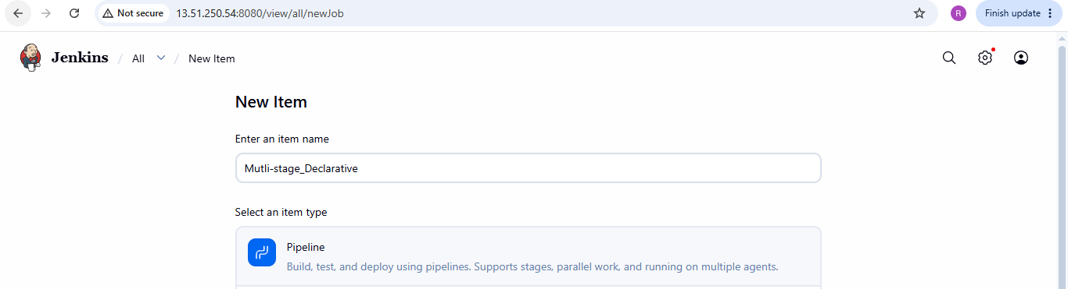

2. Configure the Pipeline
You will see the job configuration page.
Scroll down to the Pipeline section.
Set: Definition: Pipeline script

Then write Multistage declarative Pipeline code into the Script box.
Save the Job
Since pipeline contains SonarQube, Maven, Nexus, Tomcat and Slack, make sure these are configured before running it.

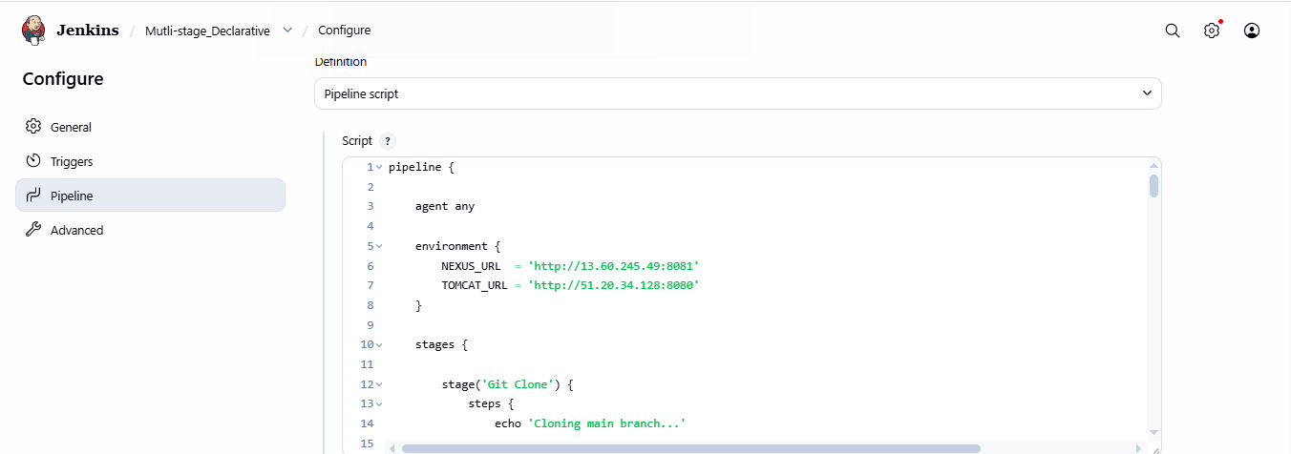

3. Run the Pipeline
On the pipeline job page, Click: Build Now
Jenkins will create: Build #1
Click the build number, for example: #1
Job is successfully executed:
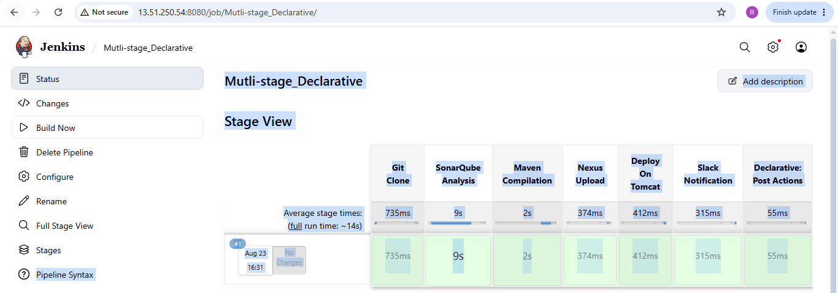

Console output of the job:
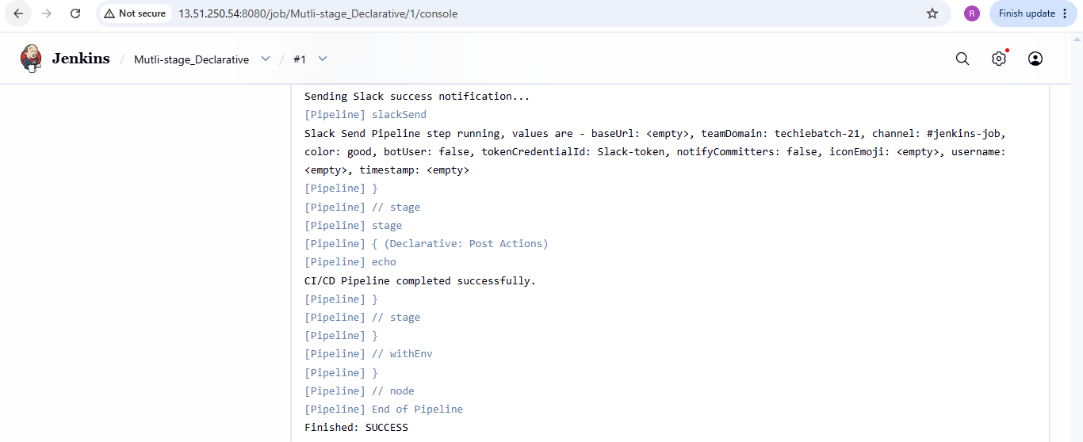
Verified the slack notification:
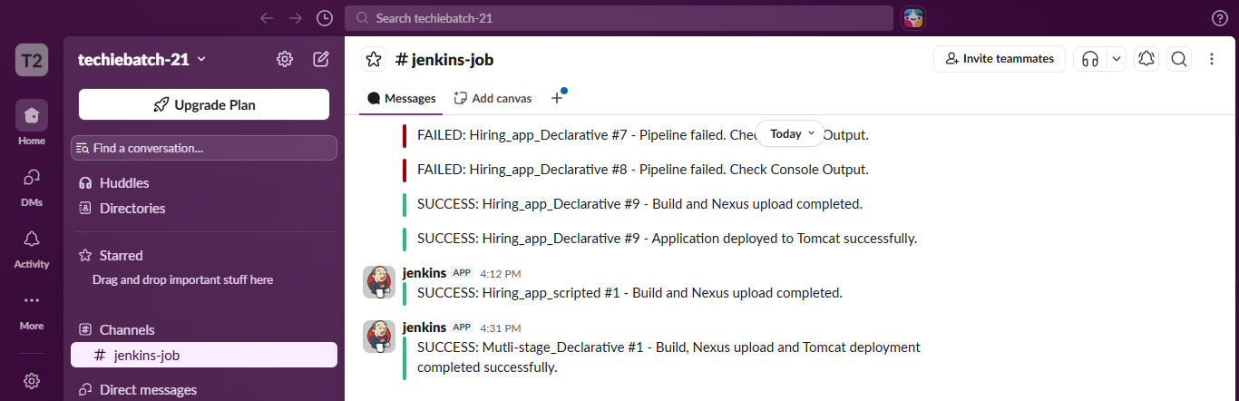

4. Create one parallel stage pipeline job
Opened Jenkins → New Item
• Entered job name: Multistage _declarative
• Selected Pipeline
• Clicked OK

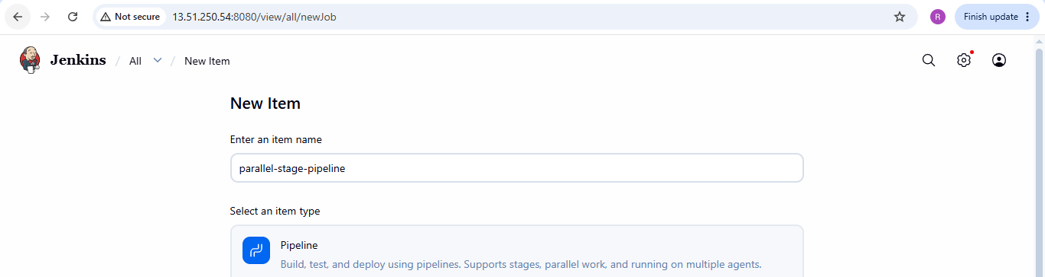 2. Configure the Pipeline
You will see the job configuration page.
Scroll down to the Pipeline section.
Set: Definition: Pipeline script

Then write Parallel stage Pipeline code into the Script box.
Save the Job
Since pipeline contains SonarQube, Maven, Nexus, Tomcat and Slack, make sure these are configured before running it.

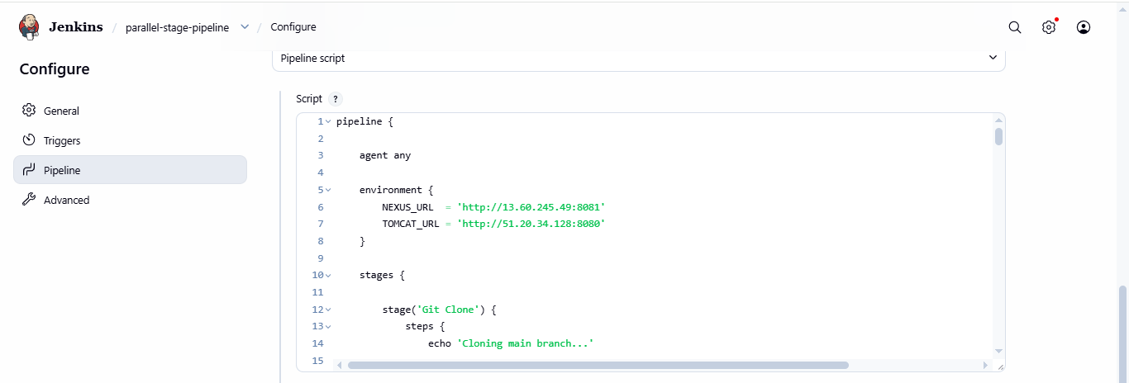

3. Run the Pipeline
On the pipeline job page, Click: Build Now
Jenkins will create: Build #1
Click the build number, for example: #1
Job is successfully executed:
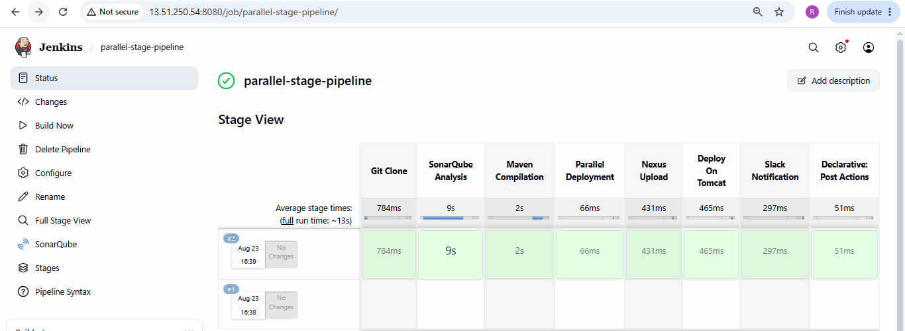

Console output of the executed job:
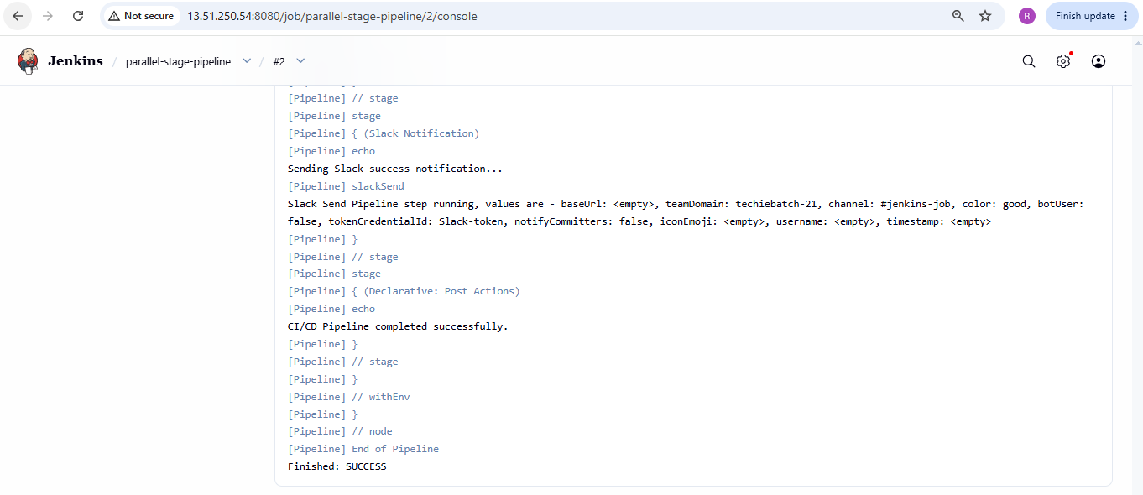

Verified the slack notification:
